**12.1 Thermodynamics and Bioenergetics\***

Biological Systems

1. Open (matter and energy can be exchanged with the environment)
2. Closed (only energy can be exchanged with the environment)
   1. Most biological studies are performed on the cellular or subcellular level rather than in an entire organism
   2. Can make useful simplifications about the internal energy, U

Enthalpy, Entropy, and Free Energy

* ΔU = Q - W and W = 0 → **ΔU = Q**
  + Changes in enthalpy in a closed biological system = changes in internal energy = heat exchange within the environment
  + No work is performed in a closed biological system because pressure and volume remain constant
* ΔG = ΔH - TΔS

Physiological Conditions

* ΔG = ΔGo + RT ln(Q)
* Free energy calculations must be adjusted for:
  + pH = 7
  + Temperature = 37oC
  + Concentrations

**12.2 The Role of ATP**

ATP as an Energy Carrier

* Mid-level energy molecule
  + Not energetically dense → high-energy bonds in ATP and the presence of a significant charge make it an inefficient molecule to pack into a small space
  + Long-term storage molecules are characterized by energy density and stable, non-repulsive bonds, primarily seen in lipids

Hydrolysis and Coupling

* Provides energy to energetically unfavourable reactions

Phosphoryl Group Transfers

* ATP can act as a phosphate donor

**12.3 Biological Oxidation and Reduction\***

Half-Reactions

* Biological oxidation and reduction reactions can be broken down into component half-reactions
* Useful to determine the number of electrons being transferred

Electron Carriers

* May be soluble or membrane-bound

**12.4 Metabolic States**

Postprandial (Absorptive) State

* Insulin secretion is high and anabolic metabolism prevails
  + Insulin promotes glycogen synthesis in liver and muscle
  + After the glycogen stores are filled, the liver converts excess glucose to fatty acids and triacylglycerols
  + Promotes triacylglycerol synthesis in adipose tissue and protein synthesis in muscle, as well as glucose entry into both tissues

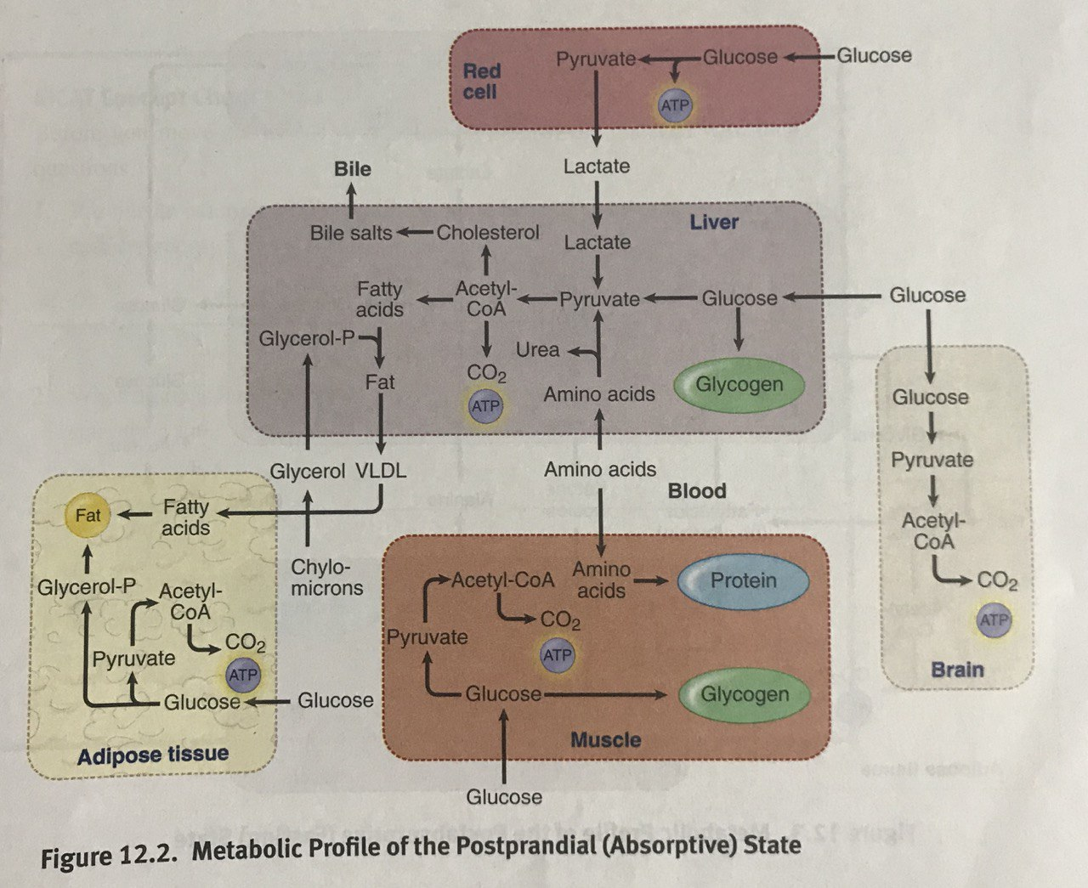

Postabsorptive (Fasting) State

* Insulin secretion decreases while glucagon and catecholamine secretion increases
  + In the liver, glycogen degradation and the release of glucose into the blood are stimulated
  + Hepatic **gluconeogenesis** is also stimulated by glucagon, but the response is slower than that of glycogenolysis
  + The release of amino acids from skeletal muscle and fatty acids from adipose tissue are both stimulated by the decrease in insulin and by an increase in levels of epinephrine
  + Once carried into the liver, amino acids and fatty acids can provide necessary carbon skeletons and energy required for gluconeogenesis

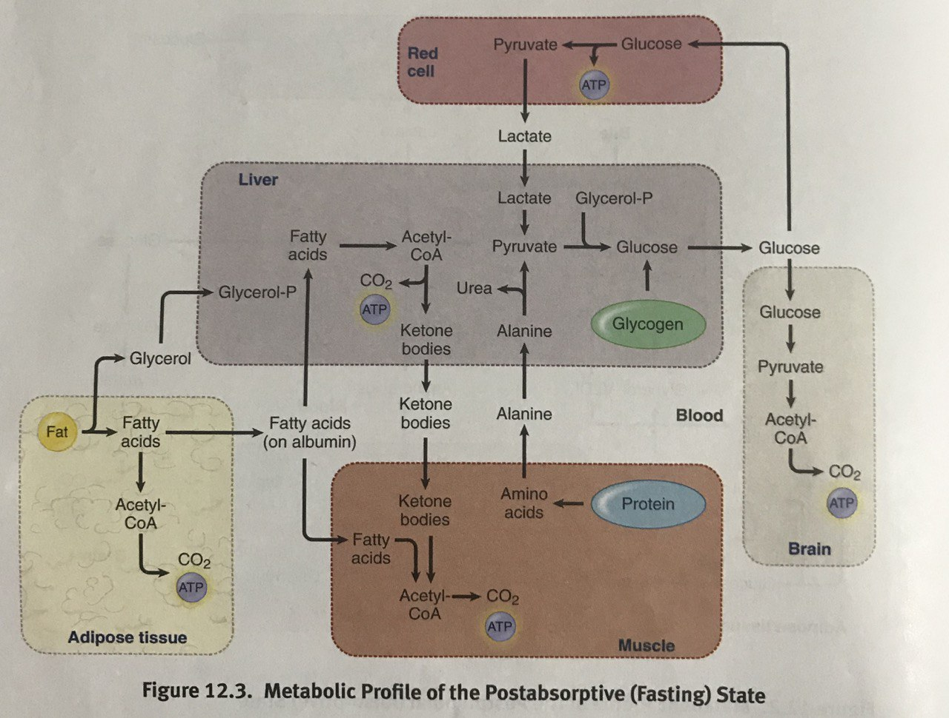

Prolonged Fasting (Starvation)

* Dramatically increases glucagon and catecholamine secretion
  + Most tissues rely on fatty acids
  + At maximum, ⅔ of the brain’s energy can be derived from ketone bodies

**12.5 Hormonal Regulation of Metabolism**

Insulin and Glucagon

* Both have opposing activities during most aspects of metabolism

1. Insulin
   1. Secretion by **pancreatic β-cells** is regulated by blood glucose levels
   2. Causes a decrease in blood glucose levels by increasing cellular uptake
   3. Increases the rate of anabolic metabolism
2. Glucagon
   1. Secretion by **pancreatic α-cells** is stimulated by both low glucose and high amino acid levels
   2. Increases blood glucose levels by promoting gluconeogenesis and glycogenesis in the liver

Glucocorticoids

* Increase blood glucose in response to stress by mobilizing fat stores and inhibiting glucose uptake
* Increase the impact of glucagon and catecholamines

Catecholamines

* Promote glycogenolysis and increase basal metabolic rate through their sympathetic nervous system activity

Thyroid Hormones

* Modulate the impact of other metabolic hormones and have a direct impact on basal metabolic rate
  + T3 is more potent than T4, but has a shorter half-life and is available in lower concentrations in blood
  + T4 is converted to T3 at the tissues

**12.6 Tissue-Specific Metabolism**

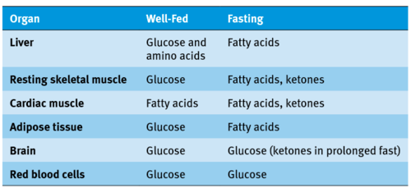

**12.7 Integrative Metabolism**

Analysis of Metabolism

* Can be measured using:
  + Respirometry (respiratory quotient = CO2 produced / O2 consumed)
  + Calorimetry (based on heat exchange with the environment)
  + Consumption tracking
  + Measurement of blood concentrations of substrates and hormones

Regulation of Body Mass

* Hormones
  + Ghrelin
    - Secreted by the stomach in response to signals (e.g. sight, sound, smell) of an impending meal
    - Increases appetite
    - Stimulates the secretion of orexin
  + Orexin
    - Further increases appetite
    - Also involved in alertness and the sleep-wake cycle
  + Leptin
    - Secreted by fat cells
    - Decreases appetite by suppressing orexin production
* Body mass can be measured and tracked using the body mass index (BMI)
* Easier to gain weight than lose weight
  + Threshold is lower for uncompensated weight gain than it is for uncompensated weight loss
  + Easier to surpass this threshold and gain weight than to lose weight